We draw N discs on a plane. The discs are numbered from 0 to N − 1. An array A of N non-negative integers, specifying the radiuses of the discs, is given. The J-th disc is drawn with its center at (J, 0) and radius A[J].

We say that the J-th disc and K-th disc intersect if J ≠ K and the J-th and K-th discs have at least one common point (assuming that the discs contain their borders).

The figure below shows discs drawn for N = 6 and A as follows:

A[0] = 1 A[1] = 5 A[2] = 2 A[3] = 1 A[4] = 4 A[5] = 0

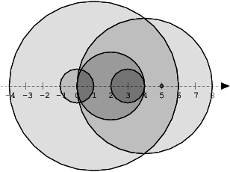

There are eleven (unordered) pairs of discs that intersect, namely:

* discs 1 and 4 intersect, and both intersect with all the other discs;
* disc 2 also intersects with discs 0 and 3.

Write a function:

def solution(A)

that, given an array A describing N discs as explained above, returns the number of (unordered) pairs of intersecting discs. The function should return −1 if the number of intersecting pairs exceeds 10,000,000.

Given array A shown above, the function should return 11, as explained above.

Write an **efficient** algorithm for the following assumptions:

* N is an integer within the range [0..100,000];
* each element of array A is an integer within the range [0..2,147,483,647].